**KPLABS Course**

**Certified Kubernetes Application Developer**

**Configuration**

## **ISSUED BY**

Zeal Vora

## **REPRESENTATIVE**

[instructors@kplabs.in](mailto:instructors@kplabs.in)

# 

**Module 1: Kubernetes Secrets**

A Secret is an object that contains a small amount of sensitive data such as a password, a token, or a key.

Allows customers to store secrets centrally to reduce risk of exposure.

Stored in ETCD database.

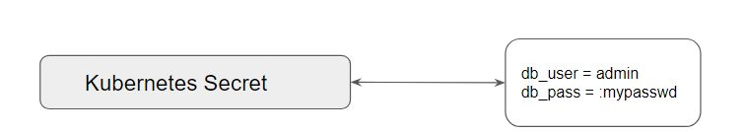

Following is the syntax for creating a secret via CLI:

kubectl create secret [TYPE] [NAME] [DATA]

Elaborating Type:

i) Generic:

File (--from-file)

directory

literal value

ii) Docker Registry

iii) TLS

Once a secret is created, it is necessary to make it available to containers in a pod.

There are two approaches to achieve this:

* Volumes
* Environment Variables.

**Module 2: Resource Limits**

If you schedule a large application in a node which has limited resources, then it will soon lead to OOM or others and will lead to downtime.

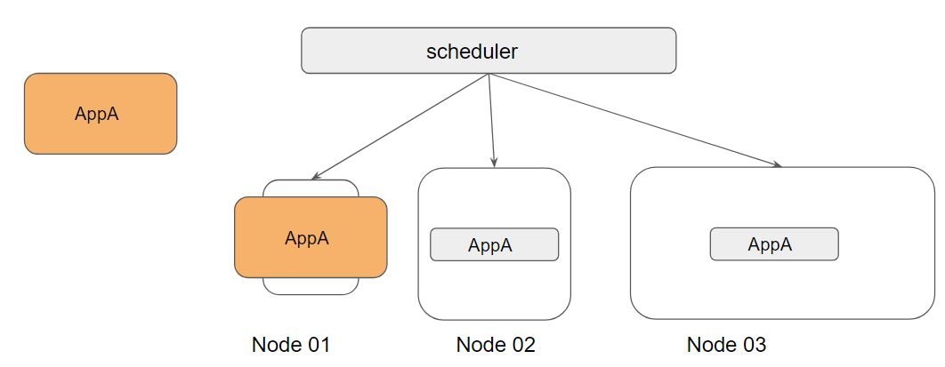

Requests and Limits are two ways in which we can control the amount of resource that can be assigned to a pod (resource like CPU and Memory)

Requests: Guaranteed to get.

Limits: Makes sure that the container does not take node resources above a specific value.

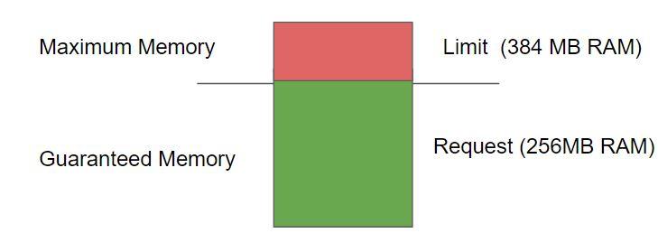

Kubernetes Scheduler decides the ideal node to run the pod depending on the requests and limits.

If your POD requires 8GB of RAM, however, there are no nodes within your cluster which has 8GB RAM, then your pod will never get scheduled.

Kubernetes Scheduler decides the ideal node to run the pod depending on the requests and limits.

If your POD requires 8GB of RAM, however, there are no nodes within your cluster which has 8GB RAM, then your pod will never get scheduled.

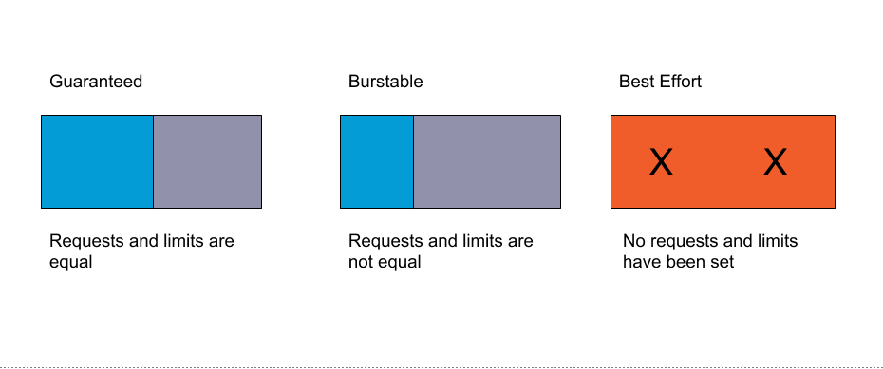

## 

## **Join Our Discord Community**

We invite you to join our Discord community, where you can interact with our support team for any course-based technical queries and connect with other students who are doing the same course.

Joining URL:

<http://kplabs.in/chat>

